|  |  |  |  |
| --- | --- | --- | --- |
| **Lyng Primary School Knowledge Organiser** | | | |
| **Topic:** | **Why was Cheddar a desirable location for Early Man?** | Year 5  Civilisation and communication | Autumn 1 |

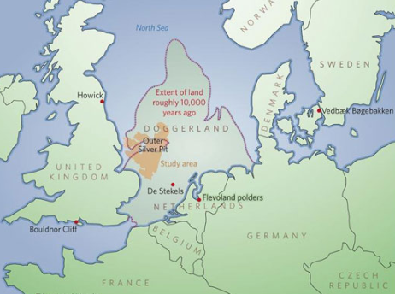

**Background information for parents and teachers**

A civilization is an advanced society with farming, division of labour, multiple cities, organized religion, science/technology, some form of government, and a written language. The main factor that allowed civilization to develop was farming. Humans were forced to live in one place and farming also provided enough food to support large numbers of people.

|  |  |
| --- | --- |
| **What Step On and Goldilocks words will I use?** | |
| **Spelling** | **Definition** |
| Valley | A valley is a low [stretch](https://www.collinsdictionary.com/dictionary/english/stretch) of land between [hills](https://www.collinsdictionary.com/dictionary/english/hill), [especially](https://www.collinsdictionary.com/dictionary/english/especially) one that has a river flowing through it. |
| Plain | A plain is a large flat area of land with very few trees on it. |
| Physical geography | the branch of [geography](https://www.collinsdictionary.com/dictionary/english/geography) that [deals](https://www.collinsdictionary.com/dictionary/english/deal) with the natural [features](https://www.collinsdictionary.com/dictionary/english/feature) of the earth's surface |
| Human geography | the branch of geography dealing with how human activity affects or is influenced by the earth's surface |
| Glacier | an [extremely](https://www.collinsdictionary.com/dictionary/english/extremely) large mass of ice which moves very slowly, often down a [mountain](https://www.collinsdictionary.com/dictionary/english/mountain) valley. |
| Forage | Looking widely for nourishment and other provisions |
| Hill fort | Settlement on top of a hill that is surrounded by a wall |
| Avalanche | A large mass of snow that falls down the side of a mountain. |
| Slough | A loose layer of snow on the surface of the slope |
| Tsunami | A very large wave, often caused by an earthquake that destroys things. |
| Dense | Something that is dense contains a lot of things or people in a small area. |
| Sparse | Something that is sparse is small in number or amount and spread out over an area. |
| Infrastructure | The stock of fixed capital equipment in a country, including factories[,](https://www.collinsdictionary.com/dictionary/english/road) roads, schools etc. considered as a determinant of economic growth. |
| Cataclysm | An event that causes great change or harm |
| Archipelago | An extensive group of islands |
|  | |

|  |
| --- |
| **Geographical study** |
| **Extreme Weather**   * Investigating how Stone Age people decided where to live and how the change of the seasons and weather affected this. * Create a model Doggerland and Britain using salt dough. Once dry, flood it to show how the water has covered the land and meant that Britain is an island. * In 6200 BC a tsunami ripped across the North Sea from Norway to Scotland destroying settlements and sweeping people away during winter. * Investigating how climate change has affected glaciers melting leading to rising sea levels which closed off Britain from the rest of Britain as Doggerland flooded. |

**Fieldwork Opportunities**

* **Outback2Basics trip – settlements**

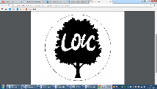

**Significant places**

* Europe (Denmark) – Bog Bodies
* Doggerland disappearing

**Our Storytelling Approach to enhance engagement**

|  |  |  |
| --- | --- | --- |
| **People:**  Torak | **Place:**  A shadowy world steeped in natural magic | **Problem:**  Kidnapped by a village |

**Key facts and locations**

**Map to be studied**

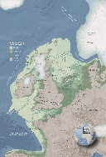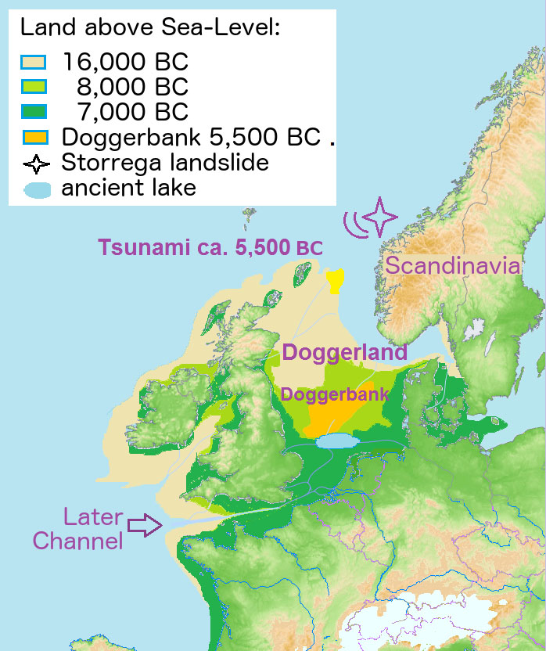

**Agreed Outcome**

A labelled map of the physical features of an area.

Doggerland used to link Britain to mainland Europe.

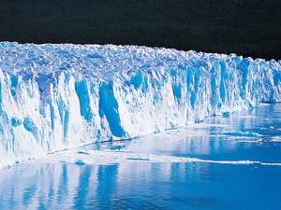

Rising climate temperatures due to naturally occurring greenhouse gases led to glaciers melting.

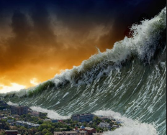

A tsunami caused by the sudden collapse of 180 miles of the continental shelf near Norway wiped out coastal areas of Scotland and Norway. This meant that tools, settlements and infrastructures were destroyed and many survivors succumbed to the first winter.

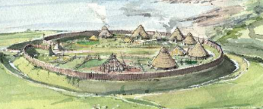

Stone Age settlers built hill forts, settled near bodies of water to hunt and fish. They built roundhouses, tombs and monuments near the coast and inland by water.

|  |  |  |
| --- | --- | --- |
| **People:**  Torak | **Place:**  A shadowy world steeped in natural magic | **Problem:**  Kidnapped by a village |

**Key skills – Taken from Milestone 3 – Sequence of Learning**

How did Stone Age migration impact world geography?

What was Doggerland and what happened to it?

How can we use maps to understand the geography of an area?

Why was Cheddar a good place to live for early humans?

|  |  |  |  |
| --- | --- | --- | --- |
| **Lyng Primary School Knowledge Organiser** | | | |
| **Topic:** | **Stone Age** | Year 5  Communication, civilisation and creations | Autumn |

|  |  |  |
| --- | --- | --- |
| 4. What is a gorge? | **S** | **E** |
| a) something beautiful in a landscape |  |  |
| b) Narrow valley between hills/mountains |  |  |
| c) A slow meandering river |  |  |

|  |  |  |
| --- | --- | --- |
| 5. What county is Cheddar in? | **S** | **E** |
| a) Somerset |  |  |
| b) Cornwall |  |  |
| c) Devon |  |  |

|  |  |
| --- | --- |
| 6. Evidence suggests that Homo sapiens first migrated from which continent? | |
| Start: | End: |

|  |  |
| --- | --- |
| 7. What happened to Doggerland? | |
| **S** |  |
| **E** |  |

|  |  |  |
| --- | --- | --- |
| 8. Which are these are NOT a continent? | **S** | **E** |
| a) Europe |  |  |
| b) Asia |  |  |
| c) England |  |  |

|  |  |  |
| --- | --- | --- |
| 1. What is the seasonal movement of humans/animals from one area to another known as? | **S** | **E** |
| 1. Travelling |  |  |
| 1. Migrating |  |  |
| 1. Moving |  |  |
| 1. Stampede |  |  |

|  |  |  |
| --- | --- | --- |
| 2. What are these lines called on an ordnance survey? | **S** | **E** |
| a) road lines |  |  |
| b) Boundary lines |  |  |
| c) Contour lines |  |  |
| d)Step lines |  |  |

|  |  |  |
| --- | --- | --- |
| 3. What do these symbols represent? | **S** | **E** |
| 1. Non coniferous |  |  |
| 1. Coniferous trees |  |  |
| 1. Coppice |  |  |